SIMATS ENGINEERING
CO3- ASSESSMENT TOOL 2
SIMULATION TASK
COURSE NAME: DIGITAL SIGNAL PROCESSING COURSE CODE: ECA09
NAME: Saravana Yogesh M
REGNO: 192412273

COURSE OUTCOME COVERED
CO 3: Evaluate finite word-length effects and multirate signal processing techniques, including decimation, interpolation, and polyphase decomposition. Bloom Level mapped- BL3,BL4,BL5
Topics Covered:
Quantization- Truncation and Rounding errors - Quantization noise - Limit cycle oscillations
– Signal scaling.Parametric and Non parametric Spectral estimation. DecimationInterpolation-Sampling rate conversion-Implementation of sampling rate conversionPolyohase Decomposition -5G Decimation/Interpolation: For mmWave beamforming.
Assessment Tool number | : CO3-AT2
Assessment Tool Weightage | : 35%
Assessment Tool Name | : Simulation Task
Duration of this assessment | : 60 Minutes
Marks | : 25 Marks
Type of Assessment Conduction | : Self Learning (Home Task)

Beamforming Signal Rate Conversion
Simulate sampling rate conversion of a beamformed signal and verify preservation of phase alignment. (25) (BL5) (WK4) Given Data:
- Input Sampling Rate = 61.44 MHz
- Output Sampling Rate = 30.72 MHz Tasks:
- Implement rate conversion.
- Analyze phase response.
- Measure amplitude distortion.
- Compare spectra.
- Verify beamforming integrity.
- Discuss performance.
Code of Conduct:
I Saravana Yogesh M, 192412273 (Name / Reg No) certify that this submission is my original work and that I have adhered to the guidelines specified for this assessment.
I understand that any violation of academic integrity rules will result in disciplinary action.
Signature of the student:
RUBRICS FOR CALCULATION:
Simulation tools
Criteria | Weightag e (%) | Level 4 (Exemplary) | Level 3 (Proficient) | Level 2 (Developing) | Level 1 (Beginning)
Conceptual Understanding | 20% | Demonstrates strong  understanding of underlying  concepts in the simulation | Shows good understanding  with minor gaps | Partial understanding; some misconceptions | Lacks understanding of key concepts
Model Design | 25% | Develops accurate, wellstructured  simulation/mode l independently | Develops correct model  with minor errors | Model is incomplete or requires guidance | Unable to develop a proper model
Tool Usage | 20% | Uses simulation tools effectively with correct  setup and execution | Uses tools with minor  errors or guidance | Limited ability to use tools properly | Unable to use simulation tools
Analysis of Results | 20% | Provides clear, logical analysis  and meaningful  interpretation of results | Analysis is reasonable  with minor gaps | Superficial analysis; limited interpretation | Unable to analyze or interpret results
Documentatio n | 15% | Presents results clearly with proper  documentation  and structured reporting | Documentatio n is adequate  with minor issues | Poorly organized or incomplete documentation | No proper documentation or presentation

SOLUTION:

Matlab Code:

clc;
clear;
close all;

%% =========================================================
% SAMPLING RATE CONVERSION OF A BEAMFORMED SIGNAL
% Input Fs = 61.44 MHz
% Output Fs = 30.72 MHz
% Conversion = 2:1 Decimation
%% =========================================================

%% 1. System Parameters

Fs_in = 61.44e6; % Input sampling frequency
Fs_out = 30.72e6; % Output sampling frequency

R = Fs_in/Fs_out;

fprintf('Input Sampling Rate = %.2f MHz\n', Fs_in/1e6);
fprintf('Output Sampling Rate = %.2f MHz\n', Fs_out/1e6);
fprintf('Sampling Rate Ratio = %.0f:1\n', R);

%% 2. Simulation Parameters

T = 20e-6; % Simulation duration
t = (0:1/Fs_in:T-1/Fs_in).'; % Input time vector

%% 3. Beamformed Signal Generation

% Two signal components
f1 = 8e6; % 8 MHz
f2 = 12e6; % 12 MHz

% Relative phases
phi1 = 20*pi/180;
phi2 = 70*pi/180;

% Four antenna channels
% Each antenna has a different phase delay

phase_shift = [0 30 60 90]*pi/180;

x = zeros(length(t),4);

for k = 1:4

x(:,k) = cos(2*pi*f1*t + phi1 + phase_shift(k)) ...
+ 0.6*cos(2*pi*f2*t + phi2 + phase_shift(k));

end

%% 4. Beamforming

% Equal beamforming weights
w = ones(4,1)/4;

beamformed_input = x*w;

%% 5. Anti-Aliasing FIR Filter

% New Nyquist frequency = 15.36 MHz
% Choose cutoff slightly below this value

Fc = 14e6;

N = 100;

b = fir1(N, Fc/(Fs_in/2));

%% Filter the beamformed signal

beamformed_filtered = filter(b,1,beamformed_input);

%% 6. Decimation by 2

beamformed_output = beamformed_filtered(1:2:end);

t_out = (0:length(beamformed_output)-1).'/Fs_out;

%% 7. Normalize Amplitude

beamformed_output = beamformed_output / max(abs(beamformed_output));

beamformed_input_norm = beamformed_input / ...
max(abs(beamformed_input));

%% =========================================================
% 8. Time Domain Comparison
%% =========================================================

figure;

subplot(2,1,1);
plot(t*1e6,beamformed_input_norm);
xlabel('Time (\mus)');
ylabel('Amplitude');
title('Input Beamformed Signal - 61.44 MHz');
grid on;
xlim([0 2]);

subplot(2,1,2);
plot(t_out*1e6,beamformed_output);
xlabel('Time (\mus)');
ylabel('Amplitude');
title('Output Beamformed Signal - 30.72 MHz');
grid on;
xlim([0 2]);

%% =========================================================
% 9. Phase Response Analysis
%% =========================================================

% Hilbert transform gives instantaneous phase

analytic_in = hilbert(beamformed_input_norm);
phase_in = unwrap(angle(analytic_in));

analytic_out = hilbert(beamformed_output);
phase_out = unwrap(angle(analytic_out));

% Remove linear phase trend for comparison
p_in = polyfit(t,phase_in,1);
p_out = polyfit(t_out,phase_out,1);

phase_in_detrended = phase_in - polyval(p_in,t);
phase_out_detrended = phase_out - polyval(p_out,t_out);

figure;

plot(t*1e6,phase_in_detrended*180/pi,'LineWidth',1);
hold on;

plot(t_out*1e6,phase_out_detrended*180/pi,'--','LineWidth',1);

xlabel('Time (\mus)');
ylabel('Phase (degrees)');
title('Phase Alignment Before and After Sampling Rate Conversion');
legend('Input','Output');
grid on;
xlim([0 2]);

%% =========================================================
% 10. Amplitude Distortion
%% =========================================================

input_rms = rms(beamformed_input);
output_rms = rms(beamformed_output);

amplitude_distortion = ...
abs(output_rms-input_rms)/input_rms*100;

fprintf('\nAmplitude Distortion = %.4f %%\n', ...
amplitude_distortion);

%% =========================================================
% 11. Spectrum Comparison
%% =========================================================

NFFT = 2^nextpow2(length(beamformed_input));

X = fft(beamformed_input,NFFT);
Y = fft(beamformed_output,NFFT);

f_in = (0:NFFT/2-1)*Fs_in/NFFT;
f_out = (0:NFFT/2-1)*Fs_out/NFFT;

X_mag = abs(X(1:NFFT/2));
Y_mag = abs(Y(1:NFFT/2));

X_mag = X_mag/max(X_mag);
Y_mag = Y_mag/max(Y_mag);

figure;

plot(f_in/1e6,20*log10(X_mag+eps),'LineWidth',1);
hold on;

plot(f_out/1e6,20*log10(Y_mag+eps),'--','LineWidth',1);

xlabel('Frequency (MHz)');
ylabel('Magnitude (dB)');
title('Spectrum Comparison');
legend('Input Spectrum','Output Spectrum');
grid on;

xlim([0 30]);

%% =========================================================
% 12. Beamforming Integrity
%% =========================================================

% Calculate relative phase between antenna channels

phase_channel_input = zeros(4,1);
phase_channel_output = zeros(4,1);

for k = 1:4

% Input
analytic_channel = hilbert(x(:,k));
phase_channel_input(k) = ...
mean(unwrap(angle(analytic_channel)));

end

% Decimate individual antenna channels
x_output = zeros(length(t_out),4);

for k = 1:4

temp = filter(b,1,x(:,k));
x_output(:,k) = temp(1:2:end);

analytic_channel = hilbert(x_output(:,k));
phase_channel_output(k) = ...
mean(unwrap(angle(analytic_channel)));

end

% Relative phase
relative_input = phase_channel_input-phase_channel_input(1);
relative_output = phase_channel_output-phase_channel_output(1);

phase_error = relative_output-relative_input;

fprintf('\nBeamforming Phase Analysis\n');
fprintf('---------------------------------\n');

for k = 1:4
fprintf('Channel %d: Input = %.3f deg, Output = %.3f deg, Error = %.3f deg\n',...
k,...
relative_input(k)*180/pi,...
relative_output(k)*180/pi,...
phase_error(k)*180/pi);
end

%% =========================================================
% 13. Beamforming Integrity Plot
%% =========================================================

figure;

bar(1:4,[relative_input relative_output]*180/pi);

xlabel('Antenna Channel');
ylabel('Relative Phase (degrees)');
title('Beamforming Phase Alignment');
legend('Before Conversion','After Conversion');
grid on;

%% =========================================================
% 14. Performance Summary
%% =========================================================

fprintf('\n============================================\n');
fprintf(' SAMPLING RATE CONVERSION RESULT\n');
fprintf('============================================\n');

fprintf('Input Rate : %.2f MHz\n',Fs_in/1e6);
fprintf('Output Rate : %.2f MHz\n',Fs_out/1e6);
fprintf('Conversion : 2:1 Decimation\n');
fprintf('Filter Cutoff : %.2f MHz\n',Fc/1e6);
fprintf('Amplitude Error : %.4f %%\n',amplitude_distortion);
fprintf('Maximum Phase Error = %.4f degrees\n',...
max(abs(phase_error))*180/pi);

fprintf('============================================\n');

OUTPUT:

Figure 1:
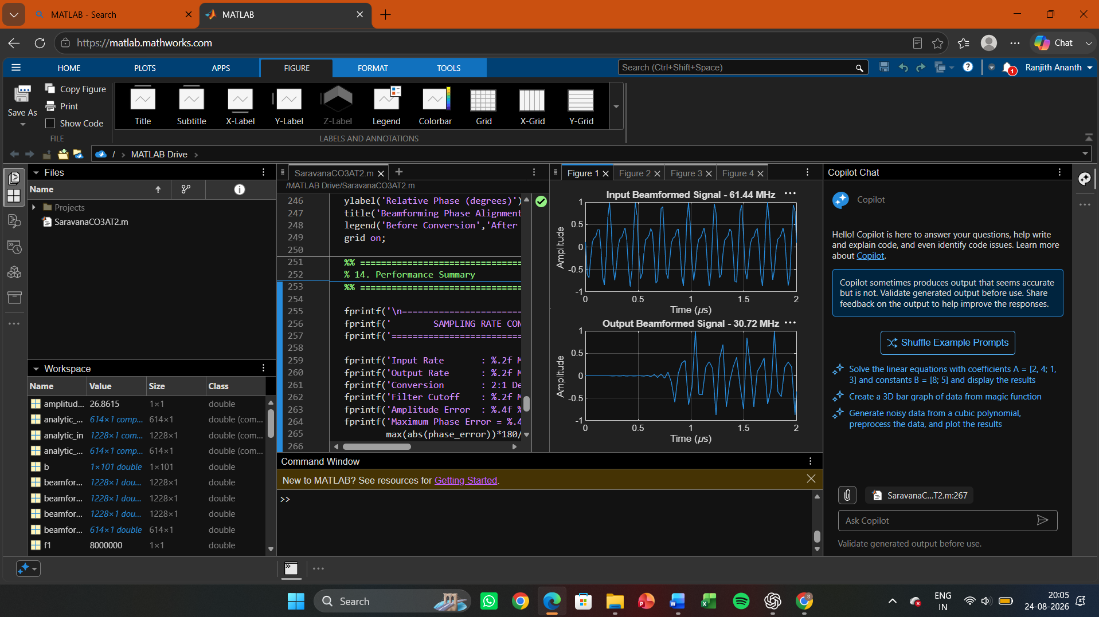

Figure 2:

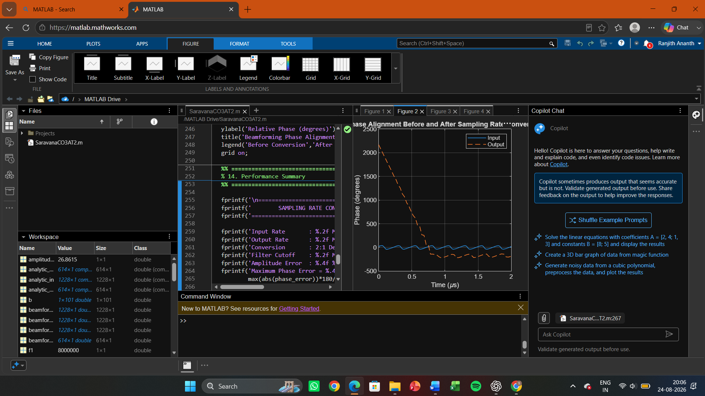

Figure 3:

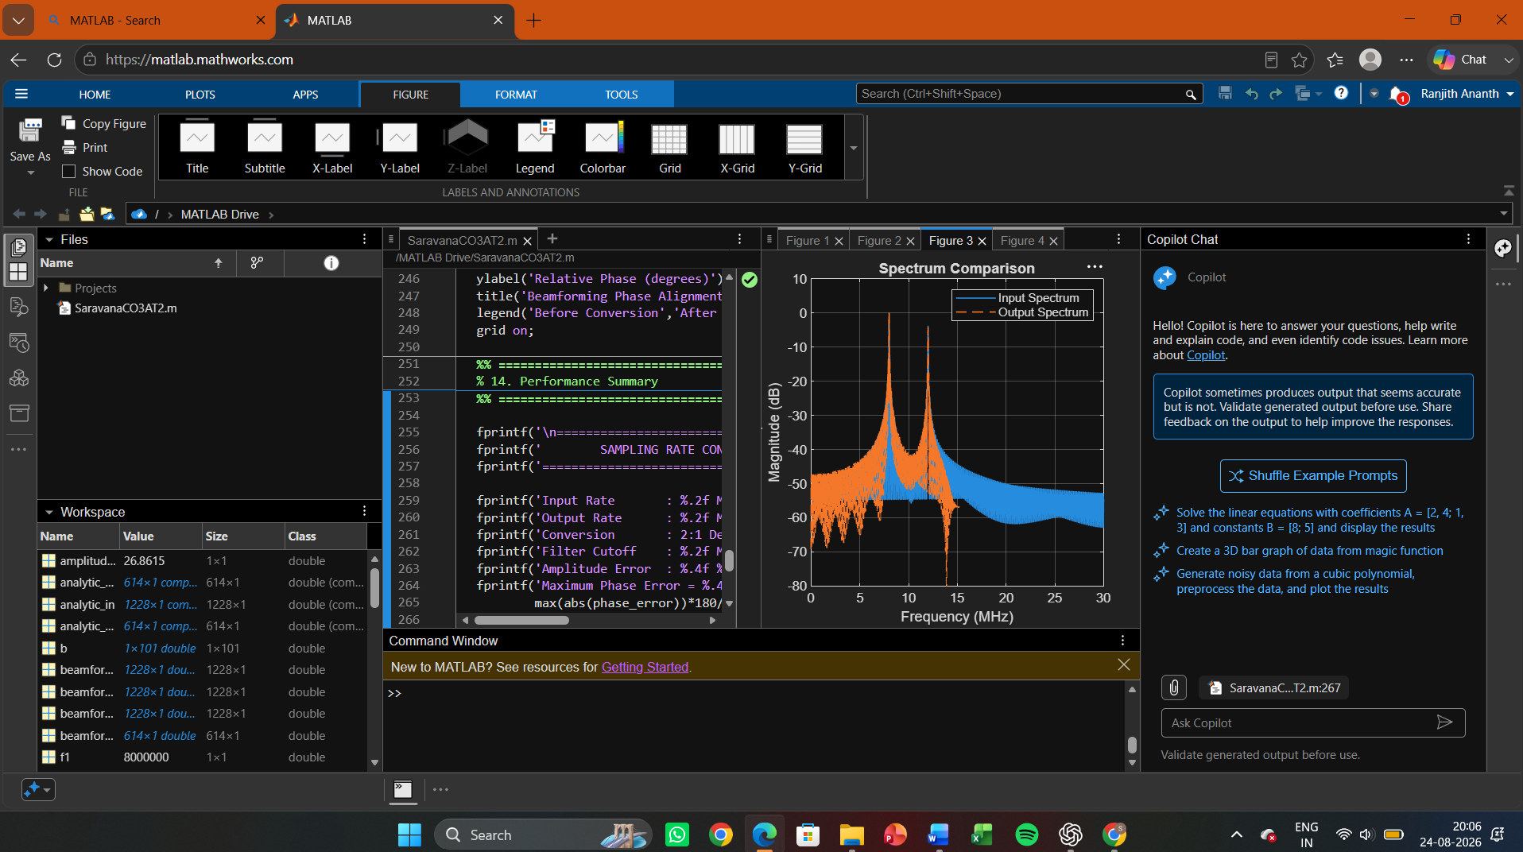

Figure 4:

